Regular Expression:
Write the RE for the language of even no. of 1’s.
∑={0,1}
W={ᴧ,11,011,101,110,1111,1100,....}
RE=(11)*

Write the RE for the language of odd no. of 1’s.
∑={0,1}
W={1,10,01,100,111,1110,.....}
RE=(11)*.1

Write the RE for the language of any length including Ʌ.(a,b)
∑={a,b}
W={ᴧ,a,b,aa,ab,aab,baa,aaaa,.....}
RE=(a+b)*

Write the RE with a string starting with a.
∑={a,b}
W={a,aa,ab,aaa,abb,.....}
RE=(a).(a+b)*

Write the RE for the language having a substring aa.
∑={a,b}
W={aa,baa,aab,baaa,aaaa....}
RE=(a+b)*.aa.(a+b)*

Write the RE with a string starting with either a or ab.
∑={a,b}
W={a,ab,aa,aba,abb,abbb,....}
RE=(a+ab).(a+b)*

Write RE with a string consists of a’s and b’s ending with abb.
∑={a,b}
W={abb,aabb,babb,aaabb,......}
RE=(a+b)*.abb

Write RE with a string consists of a’s and b’s starting with abb.
∑={a,b}
W={abb,abbb,abba,abbaa,.....}
RE=abb.(a+b)*

Write the RE for identifiers in ‘C’ Programming.
Letter=(a-z)
Digit=(0-9)
RE=(letter+_).(letter+_+digit)*

Write the RE with a string that should not start with two 0’s.
∑={0,1}
W={0,1,01,011,110,....}
RE=(01+1).(1+0)*

Write RE with a string that begins and ends with double consecutive letters.
∑={a,b}
W={aa,bb,aabb,bbaa,aabaa,bbbaa,......}
RE=(aa+bb).(a+b)*.(aa+bb)

Strings of a’s and b’s in which 3rd symbol from right end is ‘a’.
∑={a,b}
W={aaa,abb,aabb,bbabb,…}
RE=(a+b)*a.(a+b)(a+b)

Write RE for the strings consisting of atleast 1 ‘a’ followed by strings consisting of atleast 1 ‘b’ followed by strings consisting of atleast 1 ‘c’.
∑={a,b,c}
W={abc,aabc,abbc,aabbcc,aaabbc,…}
RE=a⁺.b⁺.c⁺

Write the RE for the strings over {0,1} of length 6 or less.
∑={0,1}
Length 6-{001100,110011,010101,000000,..}
(0+1).(0+1).(0+1).(0+1).(0+1).(0+1)
(0+1+Ʌ)⁶
⁽⁰⁺¹⁾⁶
^{(0+1+Ʌ)*}

Write RE for the string(a,b) whose length divisible by 3.
∑={a,b}
W={Ʌ,aaa,aba,abb,aab,aabbaa,….}
RE=(aaa+aab+aba+baa+bbb+baa+abb+bab)*

Finite Automata Construction:
M=(Q, ∑,q₀, δ, A)

- Construct DFA to accept strings of a’s and b’s having a substring aa.
W={aa,aaa,baa,aab,aabb,abaa…..}
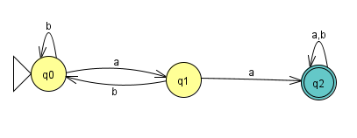
M=(Q, ∑,q₀, δ,A)
Q={q0,q1,q2}
∑={a,b}
q₀ =q0
A = q2
δ –Transition Function
δ(q0,a)=q1
δ(q0,b)=q0
δ(q1,a)=q2
δ(q1,b)=q0
δ(q2,a)=q2
δ(q2,b)=q2

- Construct DFA to accept string of a’s and b’s having exactly 1 ‘a’.
W={a,ab,ba,bba,abb,bbba,….}
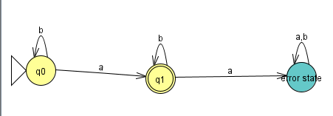
M=(Q, ∑,q0, δ,A)
Q={q0,q1}
∑={a,b}
q0 =q0
A = q1
δ –Transition Function
δ(q0,a)=q1
δ(q0,b)=q0
δ(q1,a)=null
δ(q1,b)=q1

- Construct DFA to accept strings of a’s and b’s with atleast 1 ‘a’.
W={a,aa,ab,ba,bba,baa,….}
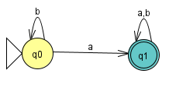
M=(Q, ∑,q0, δ,A)
Q={q0,q1}
∑={a,b}
q0 =q0
A = q1
δ –Transition Function
δ(q0,a)=q1
δ(q0,b)=q0
δ(q1,a)=q1
δ(q1,b)=q1

- Construct DFA to accept strings of 0’s and 1’s with substring 01.
W={01,001,010,011,1001,…..}
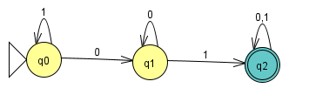
M=(Q, ∑,q0, δ,A)
Q={q0,q1,q2}
∑={0,1}
q0 =q0
A = q2
δ –Transition Function
δ(q0,0)=q1
δ(q0,1)=q0
δ(q1,0)=q1
δ(q1,1)=q2
δ(q2,0)=q2
δ(q2,1)=q2
- Construct DFA to accept strings of a’s and b' not more than 3 ’a’.
W={Ʌ,a,aa,aaa,aba,abb,bbb,aabb,…..}
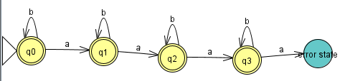
M=(Q, ∑,q0, δ, A)
Q={q0,q1,q2,q3}
∑={a,b}
q0 =q0
A = {q0,q1,q2,q3}
δ –Transition Function
δ(q0,a)=q1
δ(q0,b)=q0
δ(q1,a)=q2
δ(q1,b)=q1
δ(q2,a)=q3
δ(q2,b)=q2
δ(q3,a)=null
δ(q3,b)=q3
- Construct DFA to accept strings that end with 011.
W={011,1011,0011,11011,00011,100011…..}001000011,01100011,
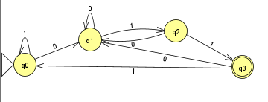
M=(Q, ∑,q0, δ, A)
Q={q0,q1,q2,q3}
∑={0,1}
q0 =q0
A = q3
δ –Transition Function
δ(q0,0)=q1
δ(q0,1)=q0
δ(q1,0)=q1
δ(q1,1)=q2
δ(q2,0)=q1
δ(q2,1)=q3
δ(q3,0)=q1
δ(q3,1)=q0

- Construct DFA to accept strings of a’s and b’s with even number of a’s and b’s.
W={Ʌ,aa,bb,aabb,abab,baba,aaaabb…}
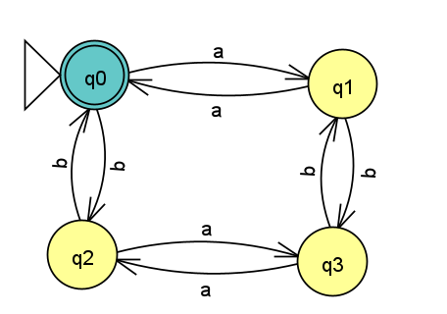
- Construct DFA with even number of a’s and odd no. of b’s.
W={b,aab,aba,baa,ababb,aaaab,aababab,….}
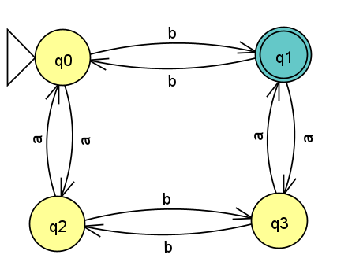
M=(Q, ∑,q0, δ, A)
- Construct DFA with odd number of a’s and even no. of b’s.
W={a,abb,bba,bab,abbaa,ababa,…..}
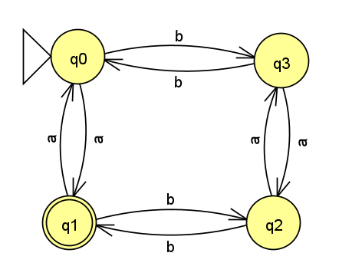ab
M=(Q, ∑,q0, δ, A)
- Construct DFA with odd number of a’s and b’s.
W={ab,ba,babb,ababab,…….}
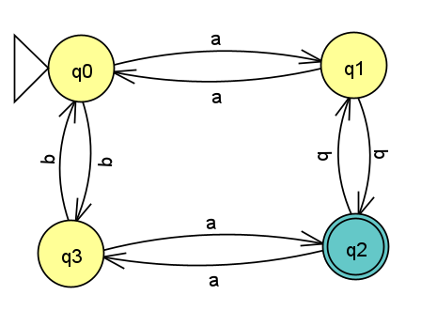
M=(Q, ∑,q0, δ, A)
- Construct DFA to accept odd and even no’s represented using binary notation.
0->0
1->1
2->10
3->11
4->100
5->101
6->110
7->111
8->1000
010
W={}
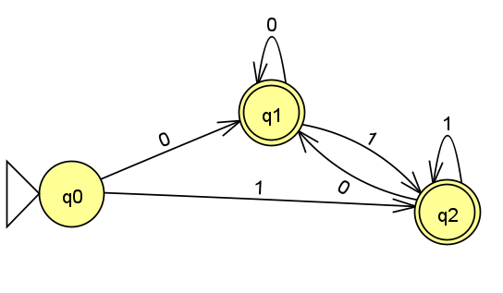
M=(Q, ∑,q0, δ, A)

- Construct DFA to accept strings of 0’s and 1’s starting with atleast 2 0’s and ending with atleast two 1’s.
W={}
M=(Q, ∑,q0, δ, A)
- Construct DFA to accept strings of a’s and b’s with atmost 2 consecutive b’s.
W={}
M=(Q, ∑,q0, δ, A)
- Construct DFA to accept strings of a’s and b’s whose length divisible by 3.
W={Ʌ,aaa,aba,aaabbb,….}ababa
M=(Q, ∑,q0, δ, A)
States | a | b
Q0 | Q1 | Q1
Q1 | Q2 | Q2
Q2 | Q0 | Q0

Qx∑=Q

Extension of δ: δ*

δ-> for one input symbol
δ=Q x ∑ -> Q
δ*->the state in which FA ends up if it begins in state q and receives a string x of input symbols
δ*(q,x) i.e. δ*: Q x ∑*->Q

Recursive Definition of δ*
Let M=(Q, ∑, q0, A , δ) be finite automata, we define the function δ*: Q x ∑*->Q as follows:
(i) for any qϵQ, δ*(q,ꓥ)=q
(ii) for any y ϵ∑*, a ϵ∑ and q ϵQ
δ*(q,ya) = δ( δ*(q,y), a)
For strings of of length 1, δ and δ* can be used interchangeably.

Find δ*(q0,abc)
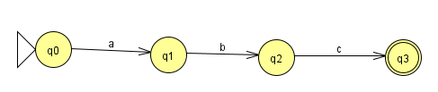
δ*(q,ꓥ)=q
δ*(q,ya) = δ( δ*(q,y), a)
ꓥa=aꓥ=a
δ*(q0,abc) = δ(δ*(q0,ab),c)
= δ(δ(δ*(q0,a),b),c)
= δ(δ(δ(δ*(q0,Ʌ),a),b),c)
= δ(δ δ(q0,a),b),c)
= δ(δ(q1,b),c)
= δ(q2,c)
=q3

String acceptance by Finite Automata
Let M=(Q,∑,q0,A, δ) be an FA. A string xε∑* is accepted by M, if
δ*( q0,x)ϵA

Language acceptance by Finite Automata
The language accepted by M or the language recognized by M is the set,
L(M)= {x | x ϵ ∑* and δ*( q0,x)ϵA}

